|  |  |
| --- | --- |
| cetlogo ***CHEMICAL ENGINEERING TRANSACTIONS***  ***VOL.*** | A publication of  aidiclogo_grande |
| The Italian Association  of Chemical Engineering  Online at www.cetjournal.it |
| Guest Editors:  Copyright © AIDIC Servizi S.r.l. **ISBN** 978-88-95608-xx-x **ISSN** 2283-9216 | |

Effect of calcination temperature and time on properties of steam exploded pellets

Liang Wanga, Lukas Baldaufa, Øyvind Skreiberga, Gøril Jahrsengeneb, Stein Rørvikb,

aSINTEF Energy Research, Sem Sælands vei 11, NO-7034 Trondheim, Norway

bSINTEF Industry, Richard Birkelands vei 3, NO-7034 Trondheim, Norway

Corresponding author: Liang Wang, Research Scientist, SINTEF Energy Research, liang.wang@sintef.no

Carbon anodes play an essential role in the production of primary aluminium. Currently fossil carbon is used for producing carbon anodes. Reducing the carbon utilization and replacing the fossil carbon are the main routes to reduce carbon footprint and increase sustainability of the aluminium production industry. Carbon anodes for aluminium production are baked in anode baking furnaces where they are surrounded and covered by packing coke from fossil sources (calcined petroleum or metallurgical coke) at high temperature for a period of up to 1-2 weeks. To reduce utilization of fossil-based coke, there is a need to identify, test and develop new packing material for use in the anode baking furnace. In this work, pellets produced from steam exploded and further pelletized stem wood were studied as a potential covering material for carbon anode production. The steam exploded pellets were calcinated at temperatures relevant to the industrial anode baking process (i.e., 1000, 1100 and 1300 ºC). The critical properties of raw and calcinated steam exploded pellets as covering material were characterized and assessed, including weight loss, volatile matter content, mechanical durability and strength. Additionally, the microstructure and ash chemistry of the pellets calcinated at different conditions were investigated by using a scanning electron microscopy (SEM) equipped with energy dispersive spectroscopy (EDX). Results showed that both volatile matter content and mechanical strength of the steam exploded pellets decrease upon increase of calcination temperature and residence time. SEM analysis revealed that untreated pellets have dense and compact structure with rather smooth and intact surface. Calcination caused formation of cracks and openings on the surface of treated pellets, partially explaining the decrease of mechanical strength of the pellets. In addition, visible migration and agglomeration of ash on calcinated pellets surfaces was observed. With increasing calcination strength, inorganic elements sinter and form a compact layer with Ca as the main element.

* 1. Introduction

Carbon anodes are used as a key material for aluminium production as they are continuously consumed during the electrolysis process. Lifetime for a carbon anode for aluminium production is about 26-28 days, which should be replaced with a new one after this period. Therefore, significant amount of carbon anodes needs to be produced and supplied. The carbon anodes are normally baked in a baking furnace at temperatures up to 1350°C [Hon et al., 2012], using two different furnace designs: open and closed top. Fossil-based materials are used during the baking process to cover the carbon anode. Calcined petroleum coke (sponge coke structure) is already available from the paste plant and is for this reason the most used packing material in both open and top furnaces. Calcined metallurgical coke or calcined anthracite may also be used in closed top furnaces [Menard Y., 2021]. The covering materials are critical for the anode baking process to 1) protect the anode against burning and consumption with presence of surrounding oxidizing gases, 2) prevent deformation of the carbon anode during heating up, and 3) efficiently transfer heat from flue gas to the anode. During the baking process, the covering material can be directly exposed to the hot flue gases, leading to reduction of mechanical strength due to continuous consumption of its carbon content [Hon et al., 2012]. It can consequently result in loss of its capacity to keep the carbon anode in its proper form and increase risk of penetration of oxidizing gas to the carbon anode. Moreover, during conversion of covering materials like metallurgical coke or anthracite, containing certain content of inorganic elements, a slag layer forms gradually. The slag acts as an additional protection against oxidizing of the uppermost coke and anode. However, during the baking process, the slag can react with refractory materials in the bricks used for building up the furnace. The slag must be removed separately after the baking process [Hon et al., 2012]. Mechanical cleaning or removing of the slag layer might result in damage or even destruction of the saggar brick walls, which must be repaired and replaced with new ones frequently. Considering this, a covering material with low ash content and slag formation is wanted.

Utilization and consumption of fossil-based covering materials causes significant emissions of CO2, a greenhouse gas (GHG) with a well-known role in the global warming and climate changes. There is a need and interest to identify, develop and test new cover material, which can replace the fossil-based covering material and reduce the CO2 footprint of the carbon anode baking process. Additionally, different requirements towards the new covering material need to be considered, including influences on anode quality, sample handling, and economical feasibility. Biomass and treated biomass are interesting covering material candidates for the anode baking process. However, in comparison to the conventional covering material, the biobased materials have considerably different physiochemical properties. More detailed and systematic studies are required to assess and characterize properties of the biobased materials to reveal their feasibility as covering material. Results from the current work can be valuable for identifying covering materials from renewable sources and reduce environmental impacts from metal production industries.

* 1. **Experimental**
     1. Material

Pellets studied in this work are made from steam exploded Norwegian softwood. For making the pellets, the softwood feedstock is dried and treated with hot steam at high temperature and pressure. After a certain residence time, the steam pressure is rapidly released, resulting in an explosive decomposition of the biomass and rupture of its rigid fibre structure. The steam exploded feedstock is further transferred to a steam driven post-drier for reduction of its moisture content and is then fed into the pellet press for making the final pellet product [Pielhop et al., 2016]. The steam exploded pellets have higher durability, bulk density and are more hydrophobic than conventional wood pellets. General properties of the steam exploded pellets are shown in Tables 1 and 2.

Table 1: Proximate and ultimate composition of the steam exploded pellets

|  |  |  |  |  |  |  |  |
| --- | --- | --- | --- | --- | --- | --- | --- |
| Volatile mattera | Asha | Fixed carbona,c | Cb | Hb | Nb | Sb | Ob,c |
| 82.14 | 0.34 | 17.52 | 51.92 | 6.15 | 0.10 | 0.01 | 41.82 |

a: wt%, dry basis, b: wt%, dry ash free basis, c: by difference

Table 2: Concentration of inorganic elements in the steam exploded pellets (mg/kg)

|  |  |  |  |  |  |  |  |  |  |  |  |  |
| --- | --- | --- | --- | --- | --- | --- | --- | --- | --- | --- | --- | --- |
|  |  | Ca | K | Mg | Na | P | S | Si | Al | Mn | Zn | Fe |
|  |  | 970 | 480 | 146 | 11 | 60 | 100 | 65 | 4 | 142 | 3 | 39 |

* + 1. Calcination of steam exploded pellet

An electrically heated furnace was employed to investigate effects of calcination on properties of the steam exploded pellets. The steam exploded pellets were loaded into alumina crucibles that were placed into the furnace. The furnace with crucibles inside were first purged with pure N2 for half an hour to flush away residual air and then heated up to the desired final temperatures with a constant heating rate of 10 °C/min. During calcination treatment and cooling down, the furnace was purged continuously with N2 gas at a flow rate of 1 L/min, ensuring that the whole process occurs in an inert atmosphere. To study the effect of highest heating temperature, the steam exploded pellets were calcinated at a temperature of 1000, 1100 and 1300°C. After each calcination test, power to the furnace was switched off as the temperature reached the desired temperature without further holding. The residues were kept cooling down in the furnace to the room temperature.

* + 1. Analysis of raw and calcinated steam exploded pellet

Key properties of untreated and calcinated steam exploded pellets were characterized by using a combination of different analytical techniques. The volatile content of untreated and steam exploded pellets were analysed by using a thermogravimetric analyser (TGA, Mettler Toledo TGA851e). The pellets, after dried at 105°C for 12 hours, were first ground into powders with size smaller than 1 mm and further loaded into an alumina crucible. The crucible was then loaded in the TGA. After purging half an hour with N2, the sample was heated up to 950 °C with a heating rate of 50 °C/min. The difference between the weight measured at the end of half an hour purging and that measured at a temperature of 950 °C was considered as volatile matter content. For each sample, the analysis was repeated 3 times and the mean value of the measured values are presented. Mechanical properties of the pellets were tested by using a pellet hardness tester (Amandus Kahl, Germany), following the procedures described in our previous work [Riva et al., 2021]. One pellet was compressed perpendicularly to the cylindrical axis direction until identification of failure of the sample. Upon observation of the failure, the applied force was recorded and used to calculate the tensile strength. For each tested sample, 3 compression strength tests were performed. Mechanical durability of the studied pellets was measured by using a tumbler (Bioenergy TUMBLER 1000+, Austria) parametrized in accordance with ISO 17831-1.). One pellet was loaded into the tumbler and rotated with a certain rotation speed and for a certain duration. The mechanical durability of the tested pellets was expressed as the percentage of the pellet weight remaining after the test and the initial weight. For each sample, durability of 5 randomly selected pellets were measured. Microstructure and microchemistry of untreated and calcinated pellets were examined by using a scanning electron microscope (Zeiss Ultra 55, Limited Edition), equipped with energy dispersive X-ray spectroscopy (EDS, Bruker XFlash).

* 1. Results and discussion
     1. Weight loss and volatile matter content

Figure 1 shows significant weight loss of untreated steam exploded pellets upon calcination at elevated temperatures. About 75 – 85% of the initial pellet mass is lost after calcination treatment, which is mainly related to decomposition of cellulose and lignin. During the steam explosion process, the biomass material is treated with hot steam (180–240 °C) under pressure (1–3.5 MPa), followed by release of pressure causing explosive decompression of the initial material into a fibrous dispersed solid [Pielhop et al., 2016]. The steam explosion at high temperature and pressure mainly causes degradation of hemicellulose that is extracted as a water-soluble fraction. Cellulose is largely preserved in the steam exploded material with slight depolymerization [Yu et al., 2022]. There is very small difference in terms of lignin contents in the untreated and steam exploded biomass. During the calcination process, pyrolysis and further carbonization of the steam exploded pellets take place, accompanied by decomposition of the residual carbon matrix and release of gas products [Yu et al., 2022]. It partially explains the evident mass loss of steam exploded pellets upon calcination treatment.

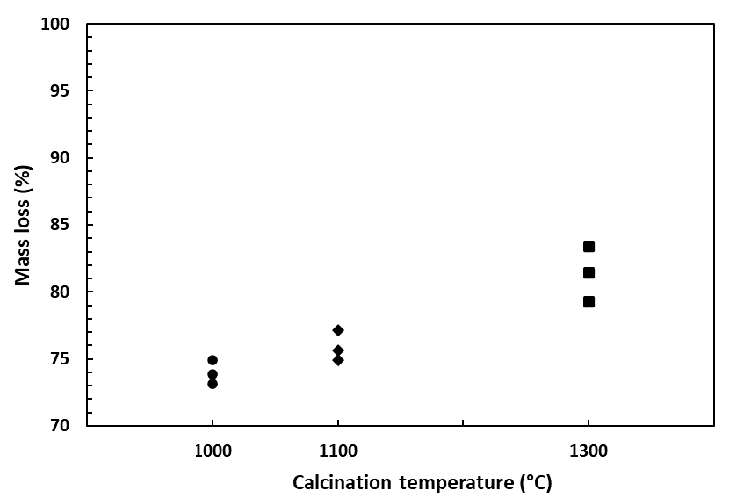

Figure 1: Weight loss of steam exploded pellets after calcination at different temperatures

|  |  |
| --- | --- |
| *Figure 2: Volatile matter content of calcinated steam exploded pellets* |  |

Figure 2 shows volatile matter content of the steam exploded pellets after calcination at elevated temperatures. Compared to the untreated pellets, the volatile matter content dropped considerably, to 4-8 wt%. The volatile matter considerably affects development of porosity and bulk density of the covering material during the carbon anode production process. Intensive release of volatile material from the covering material will result in forming of porous material due to local expansion and cracking of the carbon matrix, which causes reduction of hardness and strength of the calcinated covering material [Riva et al., 2021]. Therefore, the volatile matter content is an important quality indication of the covering material. In general, a covering material with low volatile matter content is desired for anode baking purpose.

* + 1. Mechanical properties

Figure 3 and 4 shows mechanical durability and strength of untreated and calcinated steam exploded pellets. Upon calcination, the mechanical durability of steam exploded pellets considerably decreased as shown in Figure 3, indicating higher potential to generate dust and fines for calcinated pellets. But change of mechanical durability is rather small, which decreases from 90-92% to 87-90% as shown in Figure 3. In addition, deviation of measured mechanical durability between randomly selected pellets is larger for the pellets calcinated at 1300°C. Figure 4 shows that the strength of calcinated steam exploded pellets is lower than for untreated pellets. With calcination treatment, the strength of steam exploded pellets decreased as the calcination temperature increased from 1100°C to 1300°C. The mechanical strength of one material indicates its capacity to withstand pressure, cracking and breaking due to crushing force. The mechanical durability and strength of the biomass pellets are mainly related to physical forces bonding particles together [Riva et al., 2021]. Degradation of hemicellulose and cellulose polymers have been suggested as one main reason for loss of strength of biomass pellets upon thermal treatment [Wang et al., 2020]. During calcination, decomposition of these polymers results in loss of bonds between them, disrupting and reducing the load-sharing capacity of the polymer matrix [Wang et al., 2020]. Additionally, release of volatiles and products due to decomposition of polymers will also cause formation of voids in and between particles, weakening contacts and adhesive forces between particles. Therefore, decrease of mechanical durability and strength can be mainly related to combination of decomposition of polymer constitutes and loss of bonds between particles

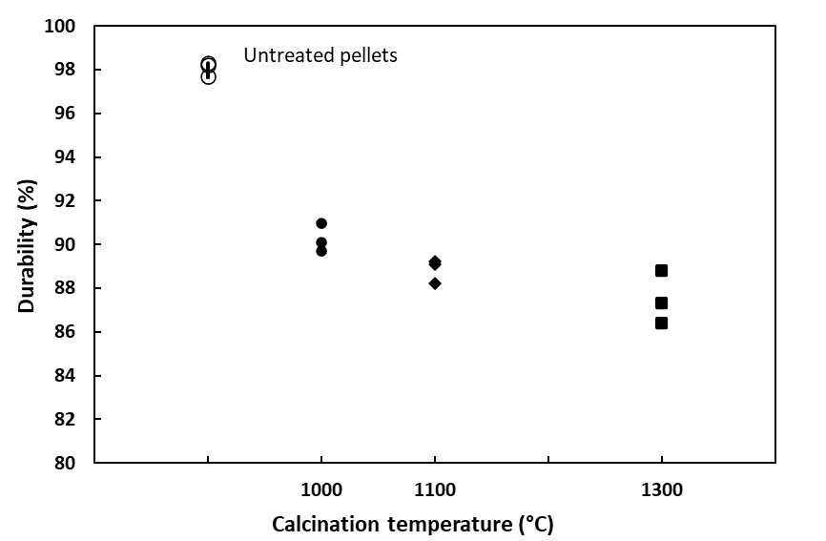

Figure 3: Mechanical durability of untreated and calcinated pellets

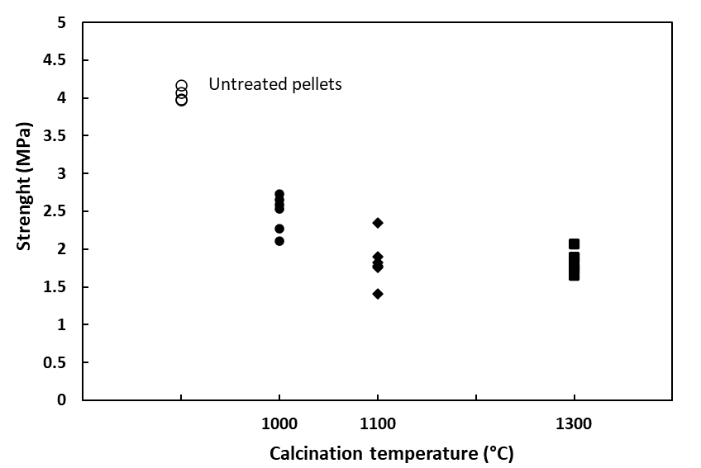

Figure 4: Mechanical strength of untreated and calcinated pellets

* + 1. SEM-EDX analysis

Figures 5 and 6 show representative SEM-EDX analysis results obtained from untreated and calcinated pellets. SEM analysis (Figure 5) reveal evident differences in the surface morphology of the studied pellets. As shown in Figure 5(a), the untreated pellet has intact and smooth surface, indicating its compact and dense structure. The surface of the pellet after calcination at 1000°C becomes coarse with observation of cracks and openings (Figure 5(b)). After calcination at 1100°C, the initial intact surface of the steam exploded pellet is no longer preserved. Large cracks and openings with different sizes can now be clearly observed in Figure 5(c).

*

2

1

2

1

2

1

d

c

b

a

*Figure 5: Surface morphology of untreated pellets (a) and pellets calcined at (b)1000, (c)1100 and (d)1300 °C*

*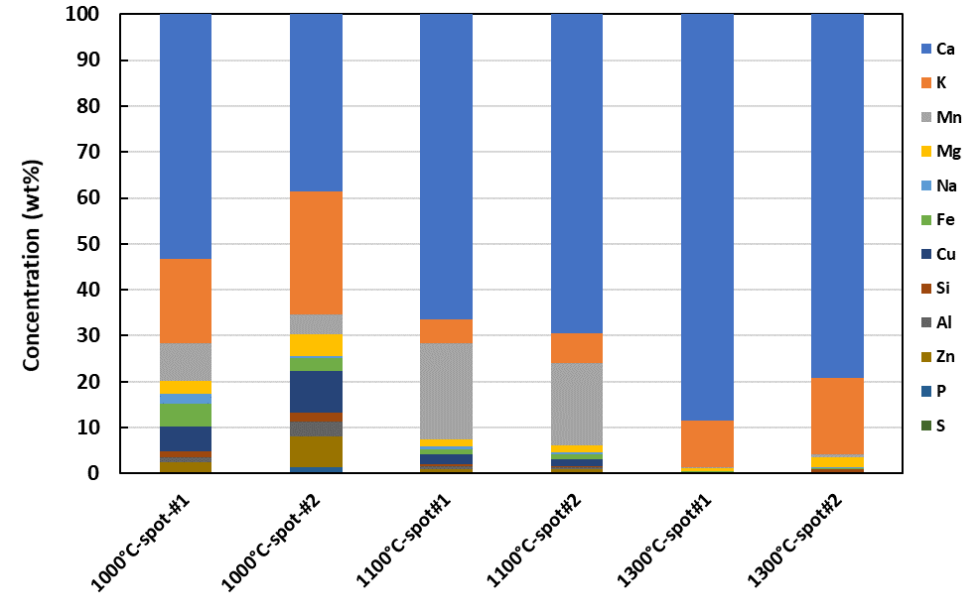*

*Figure 6: EDX analysis on steam exploded pellets calcined at 1000, 1100 and 1300 °C*

Figure 5(d) displays distinctly different surface morphology of the steam exploded pellet after calcination at 1300°C. There are sintered and agglomerated materials in light grey color, with carbonaceous material in dark grey color beneath. The uppermost material contains mainly the inorganic elements Ca, K, Mn and other elements in minor amounts. The material in dark grey is remaining char from the pellet after the calcination treatment. Figure 5(d) indicates migration of inorganic elements from within the pellet, which accumulate and agglomerate on the surface of the char. With continuous accumulation, agglomeration and sintering of inorganic elements during calcination treatment, a protective ash layer can form and hinder contact between the char and the surrounding gases, similar to what currently is happening when using metallurgical coke or anthracite as packing materials. The protective layer will slow down heterogeneous reactions and consumption of the char from steam exploded pellets, which will maintain the role as covering material for anode baking for a longer time. As such, a layer of bio-material may also be placed on top of the regular packing materials (e.g. calcined petroleum coke), and forming this protective ash layer may then also protect this packing material for further re-use.

Figure 6 shows EDX analysis on selected spots on the surface of steam exploded pellets after calcination at 1000, 1100 and 1300 °C. It is clear to see that the content of Ca on the surface of the calcinated pellet increase at elevated calcination temperature. It can be related to migration of Ca from the internal structure of the pellet and enrichment of Ca due to consumption of carbon on the pellet surface. Additionally, concentrations of other inorganic elements (i.e., K, Mn and P) change upon different calcination treatment. These elements have high release potential and might evaporate during the calcination process. More detailed studied on the transformation chemistry of ash during calcination of steam exploded pellets are needed, as is how these affect the refractories in the furnace. Results from these studies are important to predict and influence behaviors of the inorganic elements, aiming for formation of an inert ash layer on the calcined pellet surface.

* 1. Conclusions

In this work, the calcination of steam exploded pellets was studied with focusing on characterizing properties of calcinated pellets. The key properties of both untreated and calcinated steam exploded pellets were analysed. The results showed that calcination gave considerably reduced volatile matter content of the steam exploded pellets. The mechanical properties of steam exploded pellets were also affected by calcination treatment, which gave lower durability and strength in comparison to the raw pellets. The calcination temperature has mild effects on mechanical properties of the steam exploded pellets. After calcination at 1300 °C, clear accumulation and agglomeration of inorganic elements were observed on the surface of the calcinated pellet surface.

Acknowledgments

The authors acknowledge the financial support from the Research Council of Norway and the BioCarbUp project industry partners: Elkem AS - Department Elkem Technology, Eramet Norway AS, Norsk Biobrensel AS, Eyde Cluster, Hydro Aluminium AS, and Alcoa Norway ANS.

References

Hon K., Edwards L.，Marino J., Marvin L., 2012. Improving the Precision and Productivity of Green Coke Volatile Matter Analysis, TMS Light Metals, 1267-1272.

Menard Y., 2021, Packing Material in Carbon Baking Furnaces, TRAVAUX 50, Proceedings of the 39th International ICSOBA Conference, 22 - 24 November 2021. p.537-549.

Pielhop T., Amgarten J., Rohr P.R., Studer M., 2016, Steam explosion pretreatment of softwood: the effect of the explosive decompression on enzymatic digestibility, Biotechnol Biofuels, 9, 152.

Yu Y., Wu J., Ren X., Lau A., Rezaei H., Masatsugu T., Bi X., Sokhansanj, S., 2022, Steam explosion of lignocellulosic biomass for multiple advanced bioenergy processes: A review, Renewable and Sustainable Energy Reviews, 154, 111871.

Riva L., Wang L., Ravenni G., Bartocci P., Buø T.V., Skreiberg Ø., Fantozzi F., Nielsen H.K., 2021, Considerations on factors affecting biochar densification behavior based on a multiparameter model, Energy, 221, 119893.

Wang L., Riva L., Skreiberg Ø., Khalil R., Bartocci P., Yang Q., Yang H., Wang X., Chen D., Rudolfsson M., Nielsen, H.K., 2020, Effect of Torrefaction on Properties of Pellets Produced from Woody Biomass, Energy and Fuels, 34,15343-15354.